# 3.5 Exercises for Lab

## 3.5.1. Select equivalence partitioning based inputs and make test cases after classifying them in valid and invalid compartments.

### 3.5.1.1. UI

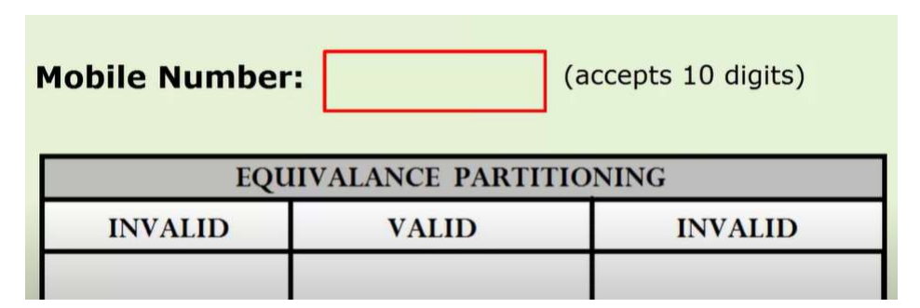

### 3.5.1.2. Partitioning:

|  |  |  |
| --- | --- | --- |
| **Equivalence Partitioning** | | |
| Invalid | Valid | Invalid |
| Mobile number digits<10 | Mobile number digits=10 | Mobile number digits>10 |

### 3.5.1.3. Test Cases:

|  |  |  |  |  |  |
| --- | --- | --- | --- | --- | --- |
| **Test ID** | **Test case Description** | **Input Data** | **Expected Outcome** | **Actual Outcome** | **Status** |
| TC_01 | To display invalid for mobile number less than 10 digits | 29292981 | Invalid mobile number |  |  |
| TC_02 | To display valid for mobile number equal to 10 digits | 1234567890 | Valid mobile number |  |  |
| TC_03 | To display invalid for mobile number greater than 10 digits | 098765432123 | Invalid mobile number |  |  |